# Introduction

This guide will provide the insight on how to install the necessary services in order to run the application locally. The application will require the following services to run:

* **Mongo Database**
* **Visual Studio Code**
* **Node.js**

The source code and the initial data will be provided in the deliverable folders under the zip file named **IMP.zip**. Inside, you will find two folders; **database** – containing the initial data; **imp-app** – source code of the application.

# Installing Mongo Database

1. Navigate to <https://www.mongodb.com/try/download/community>
2. Based on your platform and download the **MongoDB Community Server**

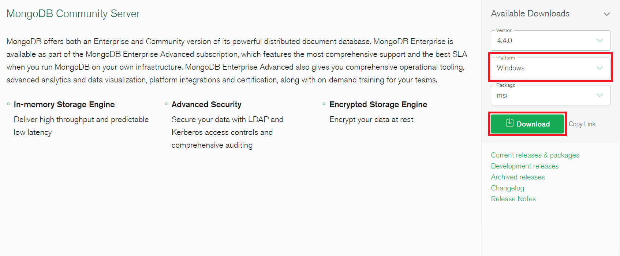

1. Run the installer

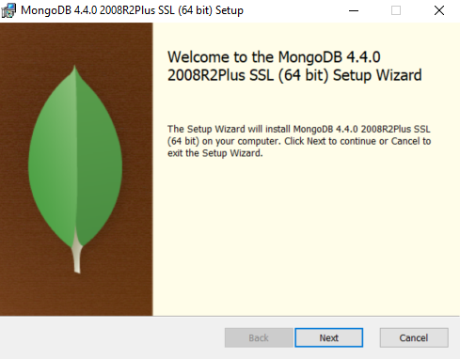

1. Click **Next** to start the setup wizard

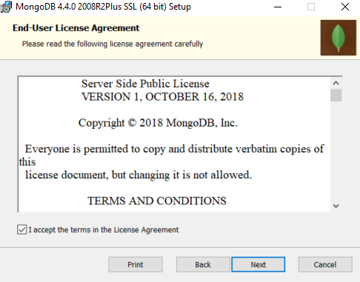

1. Accept End-User License Agreement and click **Next**

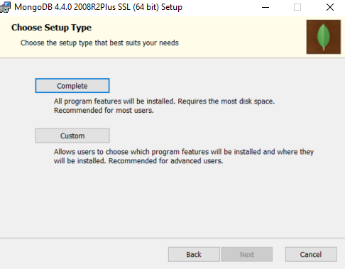

1. Choose and click **Complete** setup type

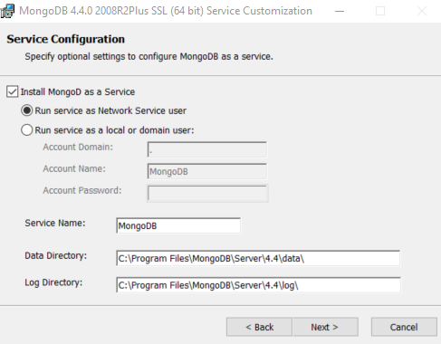

1. Click **Next>** on Service Configuration

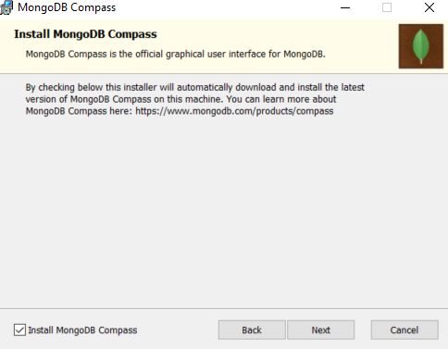

1. Select **Install MongoDB Compass** and click **Next**

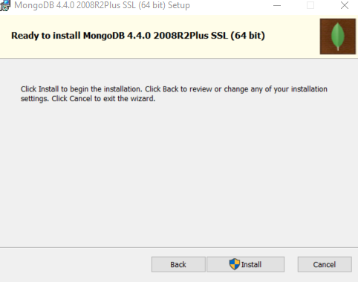

1. Click **Install** to start the installation for both Community Server and Compass Community

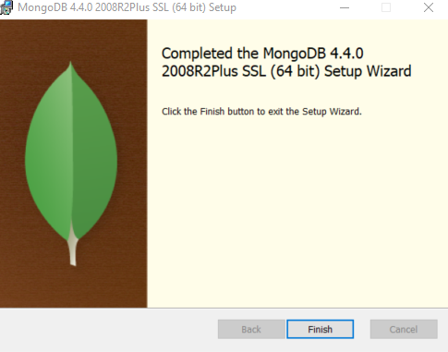

1. Click **Finish** to end the installation.
2. Open the **Command prompt** and navigate to **C drive** using **cd C:\**
3. Create a new **/data/db** directory in the **C drive** using **mkdir \data\db**
4. Navigate into the newly created directory and execute **mongod**

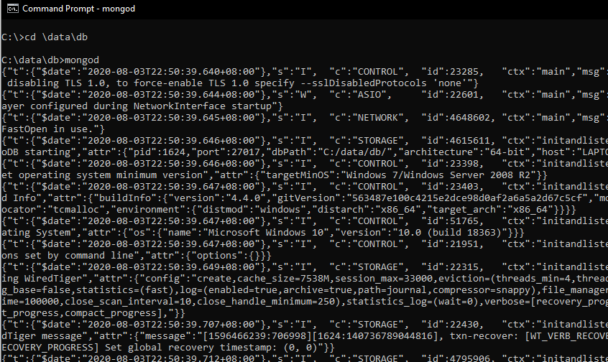

1. Open **MongoDB Compass Community** and click **Connect**

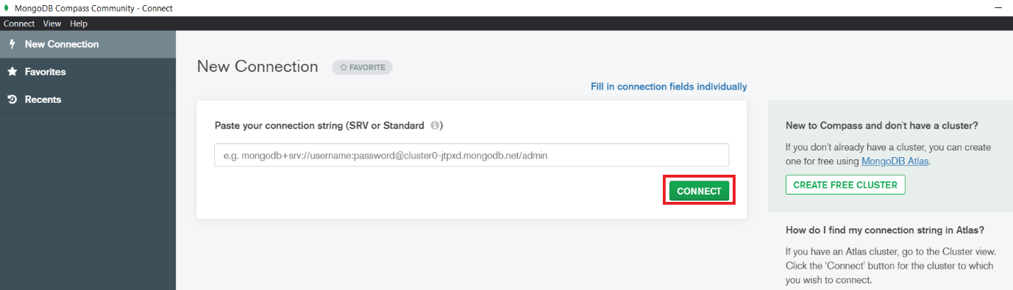

1. **MongoDB** is successfully installed if the you are connected.

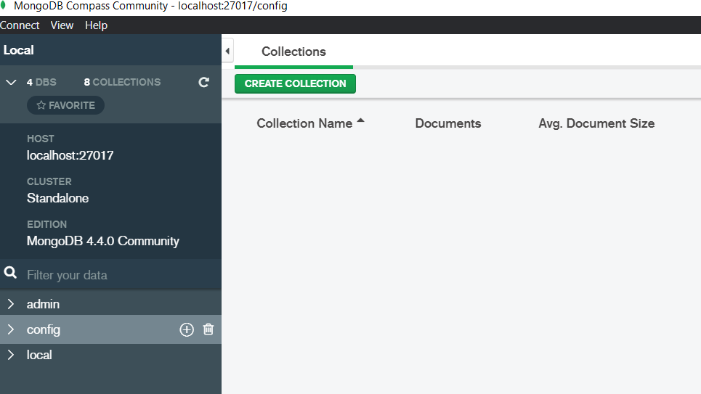

## Common Issues in installation

Certain workstation might not be able to install with ease. This are some common issue faced and the solution to it.

### ‘mongod’ is not recognized as an internal or external command, operable program or batch file

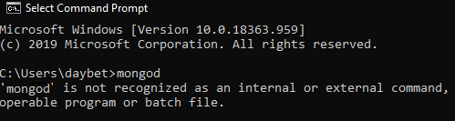

This issue can be resolve by adding the **mongodb.exe** folder to the system environment Path variable by the step provided below:

1. Open **Control Panel** change the **view by:** to **small icons**

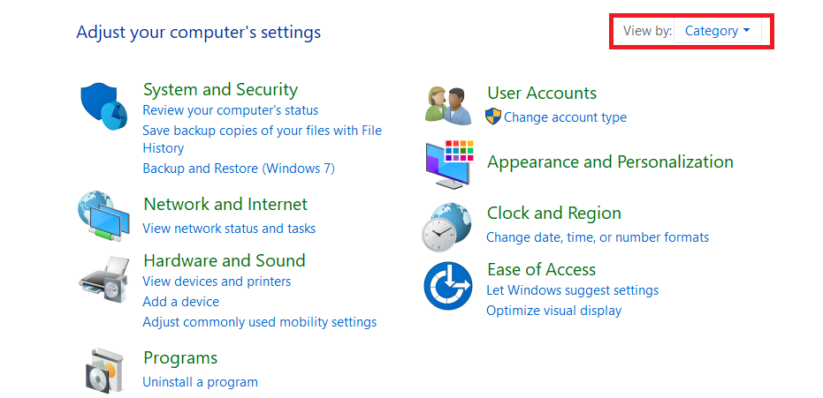

1. Find and select **system**

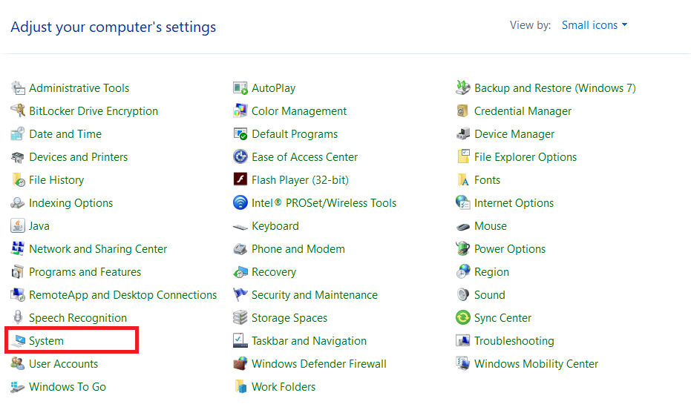

1. Click **Advanced system settings**

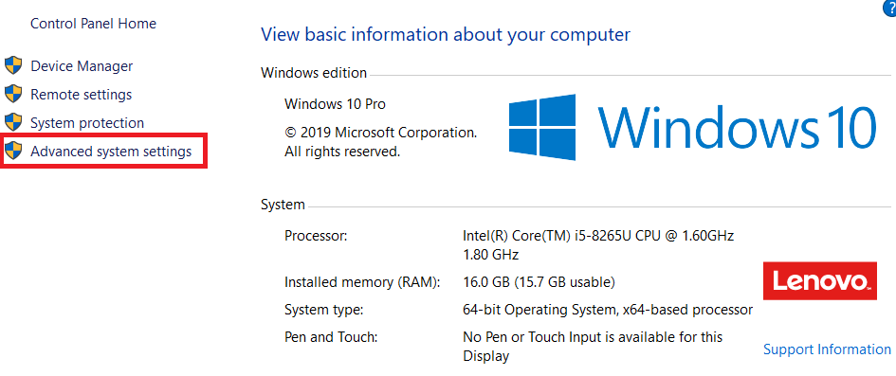

1. Click **Environment Variables..**

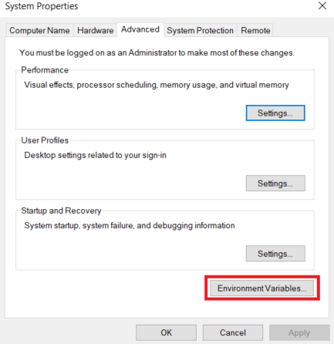

1. Under **System variable** double click on **Path**

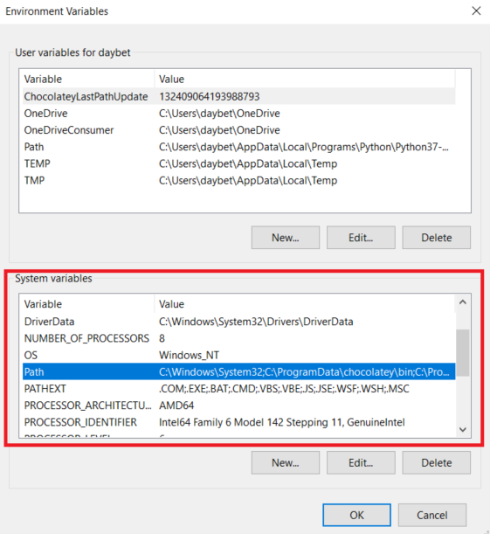

1. Click **New** and add the folder containing the **mongodb.exe**, this is normally found **C:\Program Files\MongoDB\Server\4.4\bin**

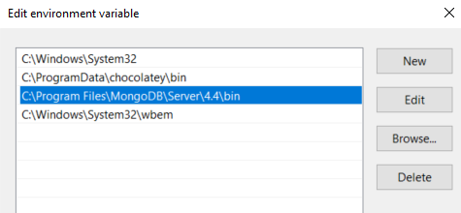

1. Click **OK** on this window and all subsequence window

### MongoDb Compass Community Stuck at Activating Plugin

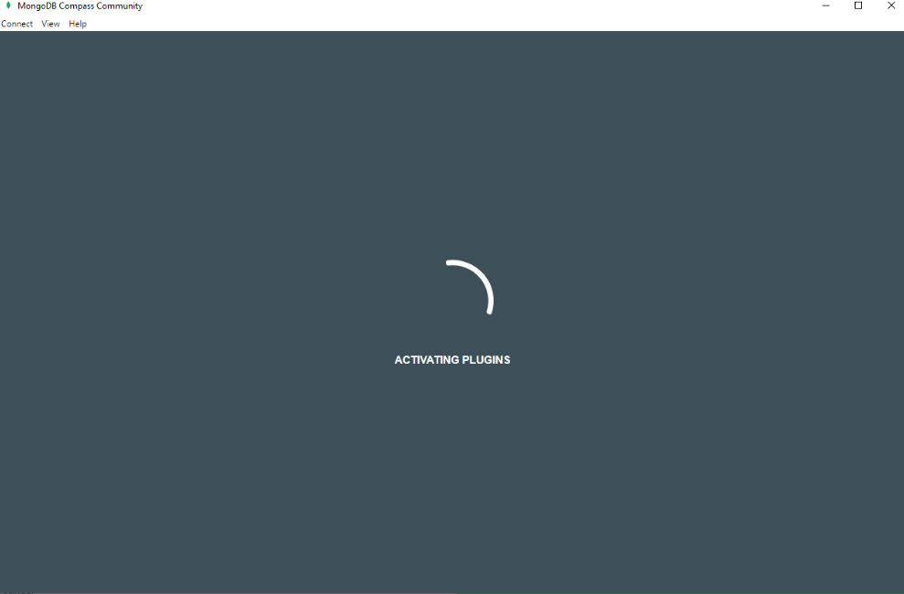

The remedy for this is to add **C:\Windows\System32\wbem** to system environment Path variable. The steps are the same as Issue1 to add the path.

# Installing Visual Studio Code

1. Navigate to <https://code.visualstudio.com/download>
2. Based on your platform, download the installer

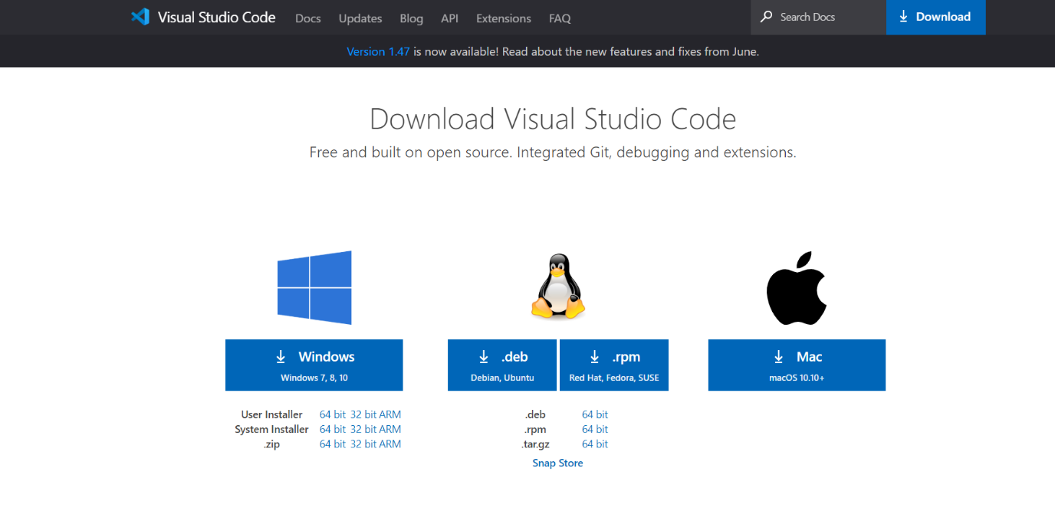

1. Once downloaded, run the installer

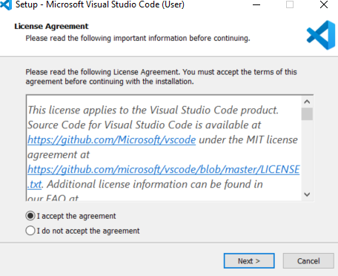

1. Select **I accept the agreement** and click **Next>**
2. Select the directory or use the default directory and click **Next>**

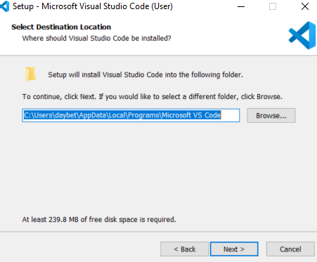

1. Select the Start Menu folder or use the default and click **Next>**

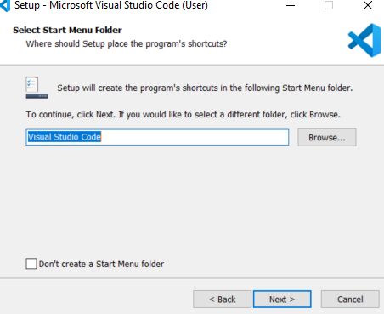

1. Check **Add to PATH** and click **Next>**

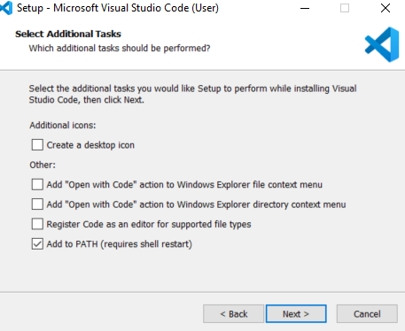

1. Click **Install** to start the installation



1. Click **Finish** to complete the installation

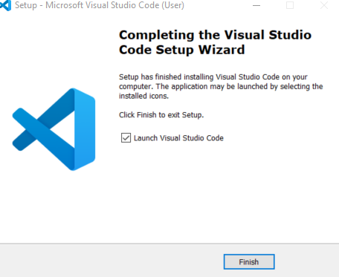

# Installing Node.js

1. Navigate to <https://nodejs.org/en/download/>
2. Based on your platform and download the installer

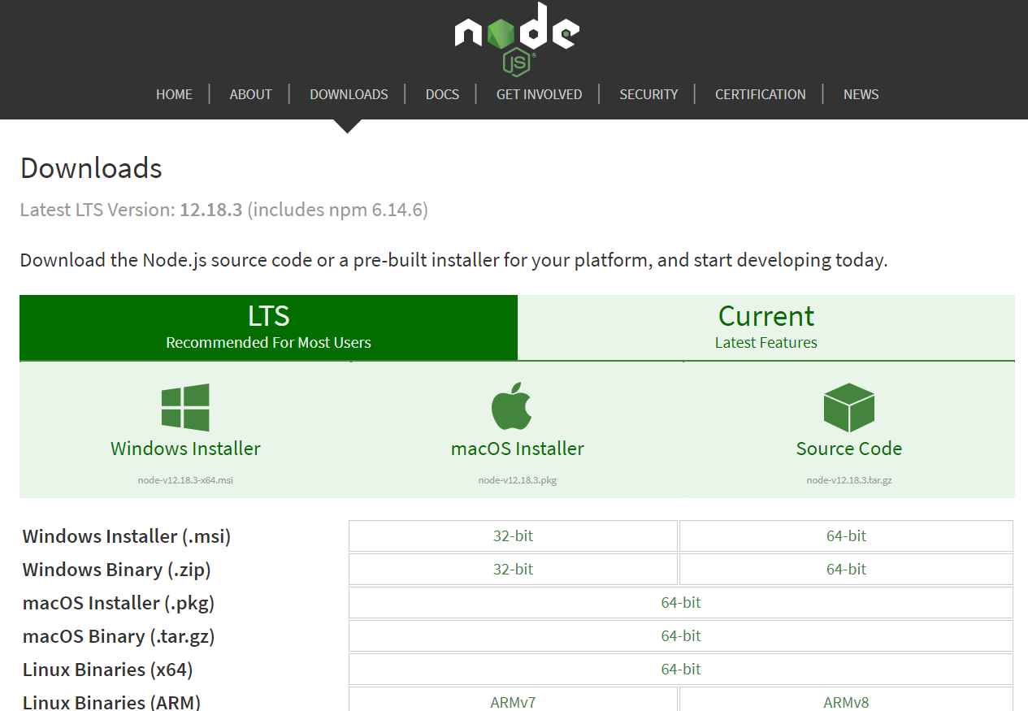

1. Once downloaded, execute the install
2. Click **Next** to start the installation

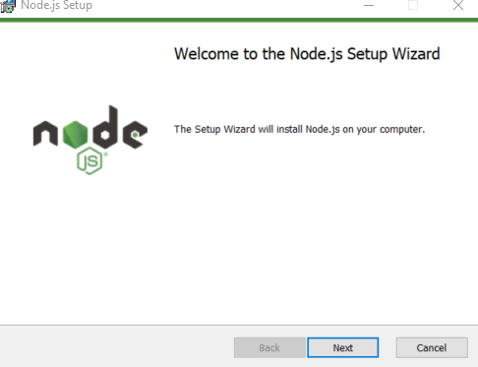

1. Accept the License Agreement and click **Next**

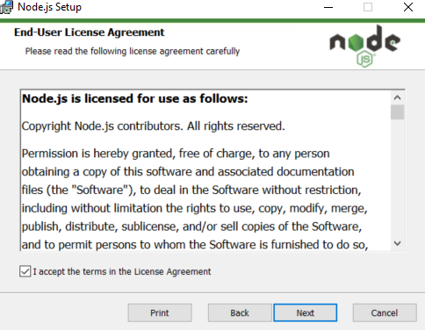

1. Select the destination folder or use the default. Click **Next**.

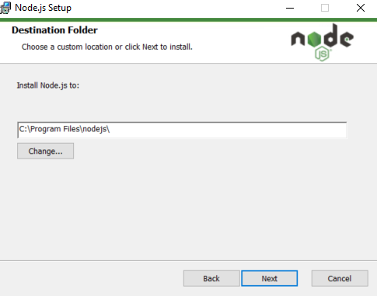

1. Use default setup and click **Next**

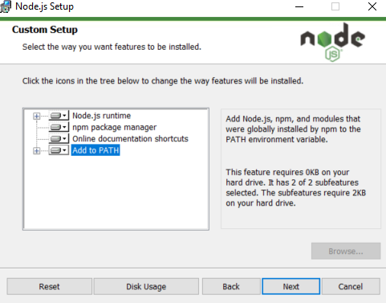

1. Check to install the native modules. Click **Next**

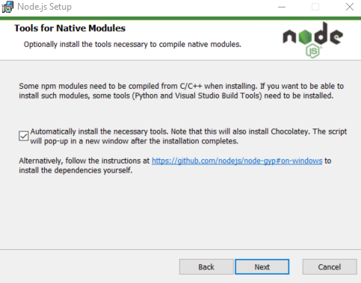

1. Click **Install** to start the installation

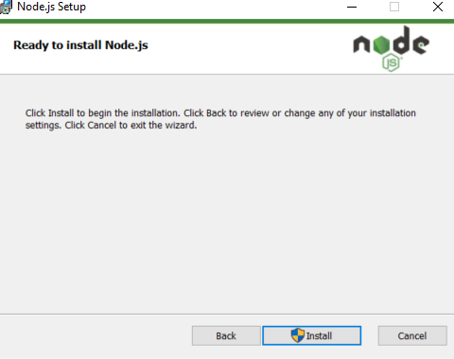

1. Click **Finish** to complete the installation

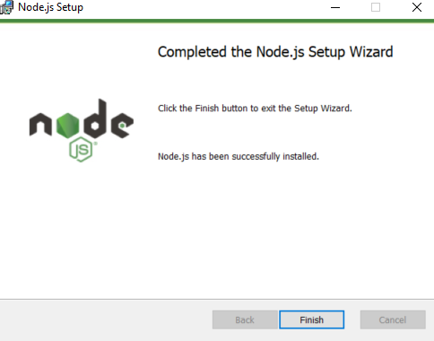

1. Open a new command line prompt and execute **npm -v** and **node -v** to ensure the node and node package manager is installed properly

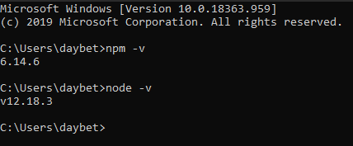

# Populating mongoDB

1. Open **MongoDB Compass Community** and click **Connect**



1. Located at the bottom left corner, click **+** to add new database

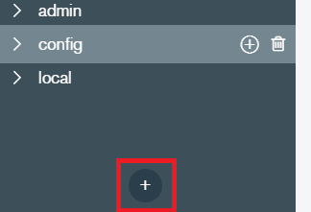

1. Enter the Database name as **IPM** and collection name as **agents**. Click **CREATE DATABASE**

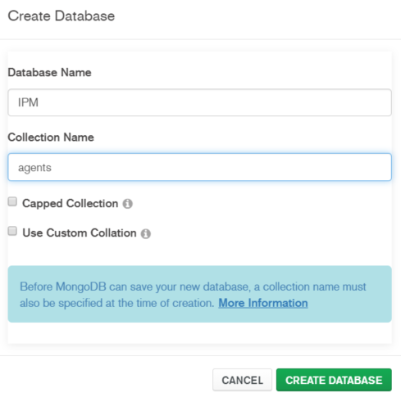

1. Click the **+** by the newly created IPM database to create the other collection

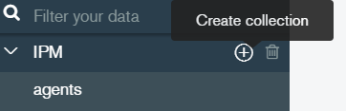

1. Create the other collection using the exact name
   1. companies
   2. policies
   3. policyholders
   4. superadmins

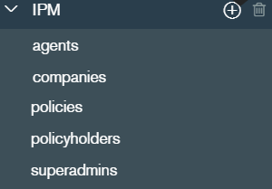

1. Open up the **database** folder in the **IMP.zipb** and locate the json files

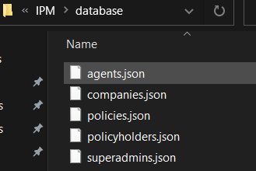

1. Select **agents** and click on **ADD DATA** then **Import File**

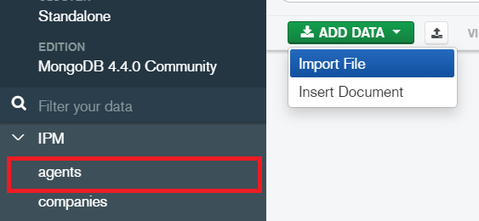

1. Click **Browse** and select agents.json. Click **Import**

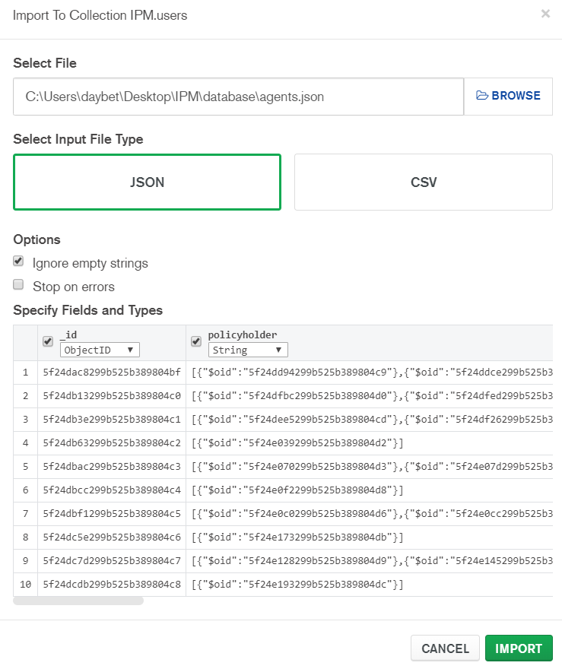

1. Repeat the same step for each of the collection

# Starting up the application

1. Open and run **Visual Studio Code**

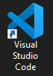

1. On the top, click **File** > **Select Folder**

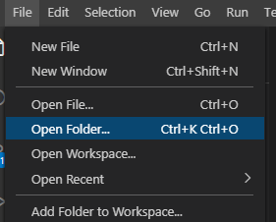

1. Select the **ipm-app** provided in the delivery files

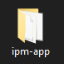

1. Within IPM-APP folder, navigate to **routes > nodemailer.js**

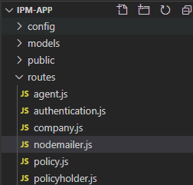

1. Locate line 21 with starting line “ let transporter = nodemail…”

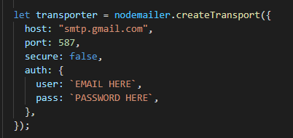

1. Depend on the mail server you using, highlight “smtp.gmail.com” and hit **CRTL** and **F2**. Type your smtp mail server. This shortcut will replace every copy with the one you have typed. If you are using Gmail, you may leave it as it is.



1. Using the same shortcut mention in VI. Replace the email and password

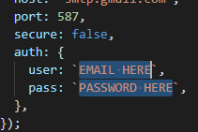

1. On the top, click **Terminal > New Terminal** to open the terminal

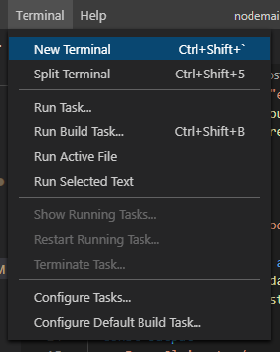

1. Execute n**pm install** in theterminal, this will download all dependencies need for the application



1. Execute **npm start** to start the application



# Note/Constraint for Application Test

* All accounts default password is **password**
* User / policy owner would require to create their own account with the same email in agent record
* The default company email follows the format: **admin@<company name>.net** whereas the company name is in lowercase.
* There are exist the four-default company, AIA, Prudential, Manulife and Aviva.
* The default email for webmaster is: **superadmin@example.com**
* Company and superadmin account are mandatory root account.
* By default the application is using json private key ‘IPM_jwtPrivateKey’, this can change at **config > custom-environment-variable.json**